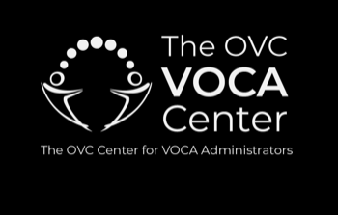

Organization Requirements
VOCA Assistance Subrecipients

34 U.S.C. 20103 (b) states:
Eligibility of program; factors; limitation on expending of sums
- A victim assistance program is an eligible crime victim assistance program for the purposes of this section if such program-
- Is operated by a public agency or a nonprofit organization; or a combination of such agencies or organizations or of both such agencies and organizations, and provides services to victims of crime

Tips for verifying nonprofit status:
- 501(c)3 organizations often submit letters from the IRS that are several years old. In this case, additional verification would be considered best practice. Additional verifications could be state verification (#2 above) or submission of the most recent 990 or 990 Extension Request.
- 990s
  - All 501(c)3 organizations must file a 990 annually to maintain their Exempt status with the IRS. The due date is based on the organizations tax year (Fiscal Year) and is available as a chart on the IRS website.
    - If an organization does not file their 990 or request an extension, they will lose their exempt (non-profit) status with the IRS. It can be granted again, however, all past due reports have to be submitted, processed and the organization has to re-apply.
  - 990s provide valuable information about the organization that is very useful in determining pre-award and post-award risk. Click here for a copy of a blank 990 to see the information provided.
  - Some states require submission of the most recent 990 as part of the application regardless of how current the IRS letter is.

